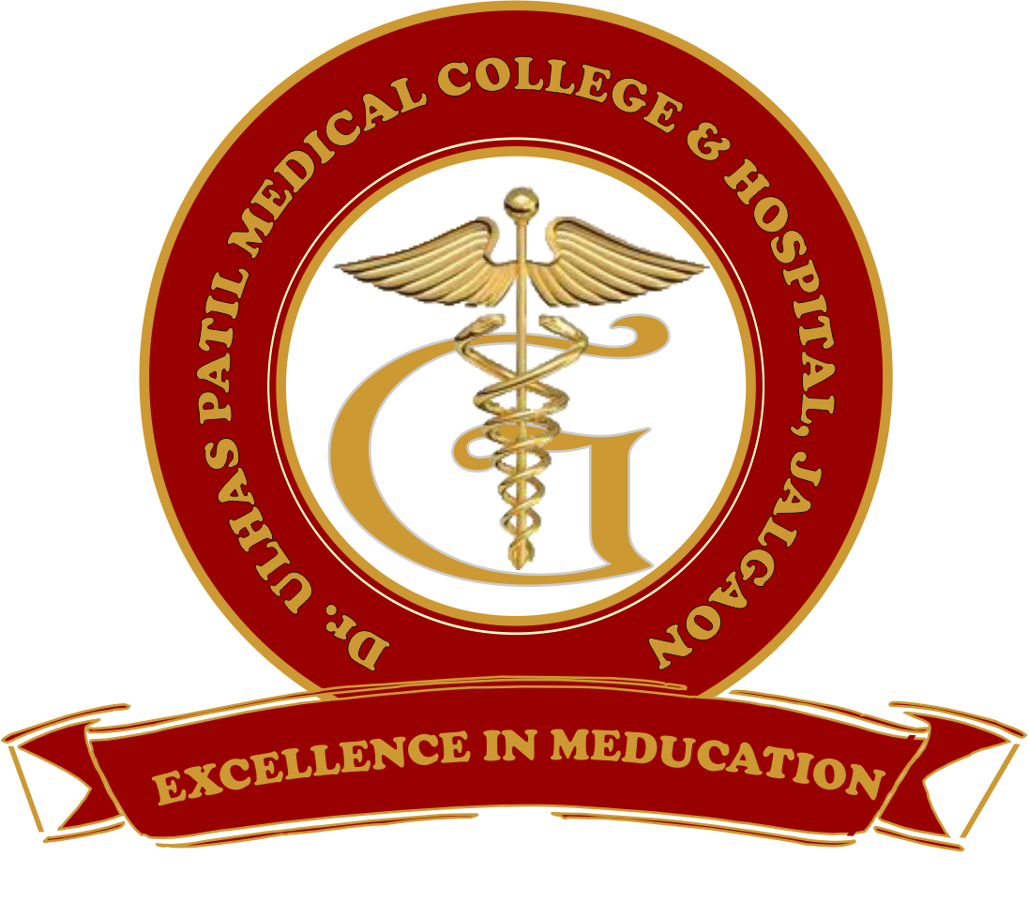 | Godavari Foundation’s  DR. ULHAS PATIL MEDICAL COLLEGE & HOSPITAL,  Recognized by Medical Council of India, Approved by Central Govt. of India, New Delhi,  Letter no. MCI-34(41)/2012-med./158127, dated 05/02/2013  Affiliated to Maharashtra University of Health Sciences, Nashik [College Code-1306]  Jalgaon-Bhusawal Road, Jalgaon Kh, Tal. & Dist. Jalgaon 425309  Tel. No. (0257)2366657, 2366678 Fax No. 0257-2366648  Email ID : dupmcj@yahoo.in Web Site : www.dupmc.ac.in

7.1.8 Describe the Institutional efforts/initiatives in providing an inclusive environment i.e., tolerance and harmony towards cultural, regional, linguistic, communal socio-economic and other diversities:
Response:
Dr. Ulhas Patil Medical College and Hospital (Godavari foundation) is one of the premium centres of higher education in Maharashtra aiming at excellence in teaching and extension activity ensuring quality, access, equity and values. The aim of the college is having a very strong vision to train the medical students with empathy and produce quality medical doctors with competent skill. Spread of knowledge how to render good service to society and acquire commanding heights in the field of medical. The values like innovation, knowledge dissemination, cutting edge research, competency building and extension activities with holistic approach are the important and perpetuate them for societal needs. The college believes in inculcating competitive spirit and human values among the students promoting peace and harmony in the society. It contributes to the amelioration of the weaker section in an economically, socially, and educationally developing region of the state of Maharashtra.
The institutional efforts/initiatives are as follows:
- All national days are celebrated at college where faculty/non-teaching staff/students gather together at the campus. Cultural activities are performed during the event. Faculty members and students take a pledge to preserve the unity, integrity, and security of the nation. It sensitizes students about the constitution of India, their duties, and responsibilities towards the nation. Programme in charge scheduled various activity which help to increase awareness in students regarding all days.
- The college celebrates religious festivals like Ganesh Festival, Christmas, Eid, etc.
- “SAMANVAY”, “AAGAZ” and many more celebrated every year in an annual social gathering by the student as well as staff where everyone comes in traditional attire representing their culture.
- “Godavari pariwar Saptahik” a weekly newspaper gives a platform to the students and faculties to express themselves to fulfill all types of needs of society.
- Staff wear apron and students wear uniform in the campus which shows uniformity and discipline.
- The college provides assistance to the students from reservation category and economically weaker section in obtaining scholarship/freeship from Goverment.
- The economically backward patients are facilitated with several BPL Programmers such as VJAY, MJPJAY, etc.
- Yearly based college brochure publication for common message to all individuals of college
Location Advantage:
DUPMC and Hospital has a leverage of its location to serve rural areas as it is having good road connectivity. This allows patients from either of the state to get easy access to this hospital. It lies in rural area hence making it easily available for the rural people. This hospital is built beside to the highway which again makes it easily accessible for emergency cases.

Dean Chairman
Dr Ulhas Patil Medical College, Jalgaon. Dr Ulhas Patil Medical College, Jalgaon.

